**Do we need to wrap our attribute values in quotation marks?**

Great question isn't it?

As you may remember, in the lecture we wrote this:

<button onclick=boom()>

Weird right?

Shouldn’t it have been like this:

<button onclick=**"**boom()**"**>

Lets take a step back

The starting point is to remember that when we write an inline event listener within our HTML, it is really an attribute of that HTML element.

In other words, its no different to having another type of attribute like a '**class**' attribute: <button class=”beautifulClass”> or a '**type'**attribute: <button type=”button”>, or a ton of other attributes.

The only difference is that in our case, the attribute we’re using is onclick.

Unquoted attribute values

This may or may not blow your mind, but we don’t always have to have quoted attribute values. In fact, the following is **VALID**html:

<button type=button> or <button class=beautifulClass> or more specifically <button onclick=boom()>

**Important: an attribute value can be used without quotes under certain conditions.**

What conditions?

Well there are a lot of intuitive rules. If your attribute value has spaces in it, then things will break. This will work:

<button class="beautiful funky">

But, as I'm sure you already know, this will break:

<button class=beautiful funky>

Why does the second one break?

The parser will interpret the above to mean:

<button class="beautiful" funky="">, and of course, funky is not a valid HTML attribute so we have a break.

What exactly does the spec say?

I don’t want to go into the HTML spec, but if you want to have a look then check it out [here](https://html.spec.whatwg.org/multipage/introduction.html#intro-early-example).  To save you time, here is a snippet I took of the relevant piece:

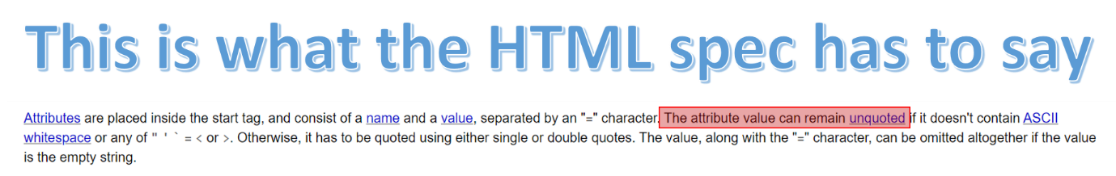

As you can see, it tells us when we are allowed to leave our attribute value unquoted. As per the spec, we are allowed to have unquoted attribute values if the value:

* does not contain spaces
* does not contain “ ‘ ` = < or >

Other than this, we have to wrap our attribute values in 'single' or "double" quotation marks.

Concluding comments

Let me finish off by saying 3 things:

1. As per the HTML spec, we don’t always need to wrap our attribute values in quotation marks
2. This is why we could write our boom() function without quotation marks. Remember, like this <button onclick=boom()>
3. **If in doubt, always wrap your attribute values in quotes (its just good practice)**

